How to create a Free AWS account

- Got to this link: https://aws.amazon.com/
- Click on the Create account button.
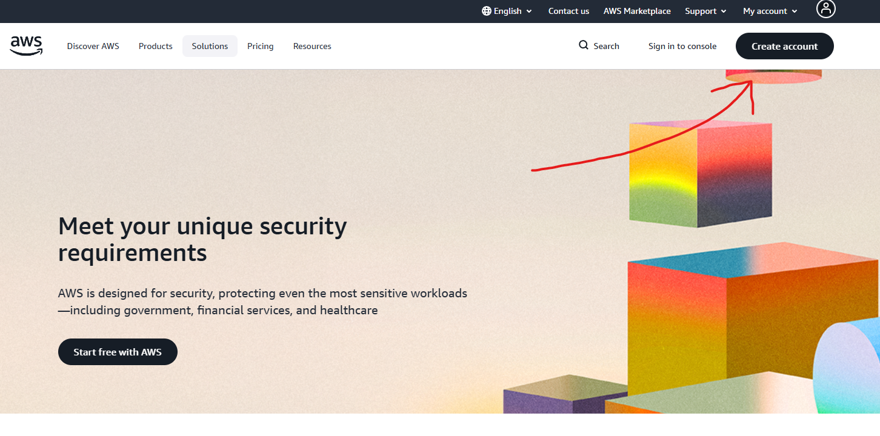
- Fill in the first box with your email and the second box with your chosen AWS account name.
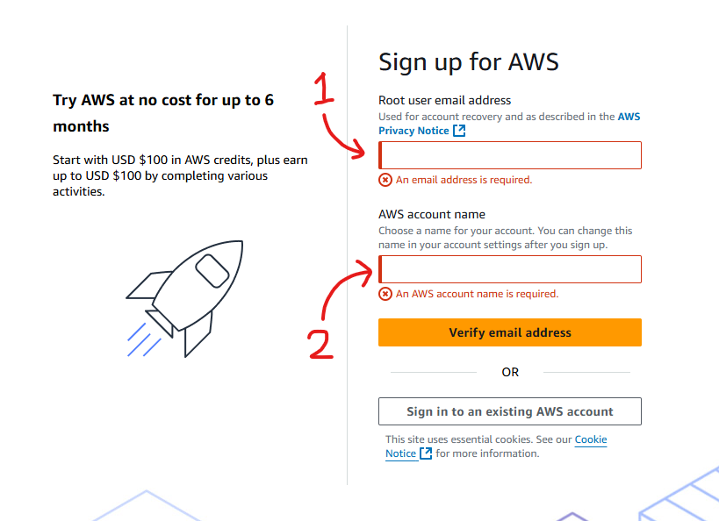
4. Verify email address

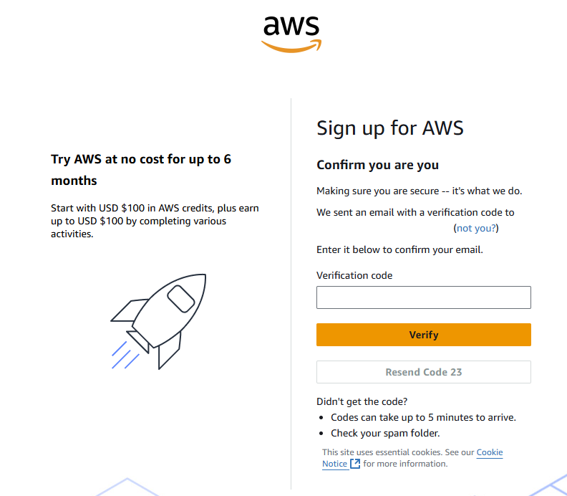
- Create password then click continue
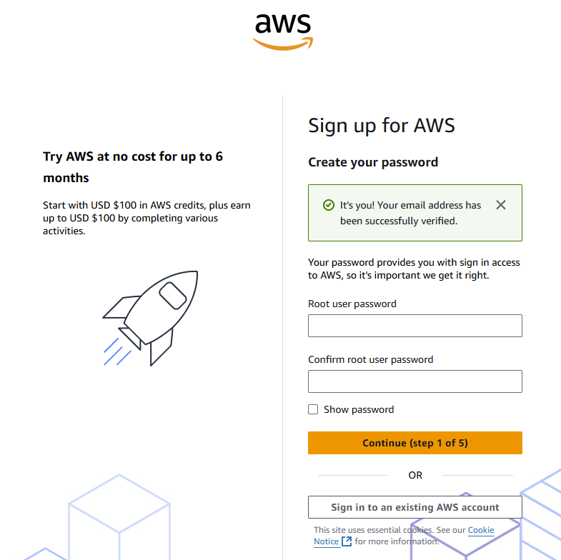
- Click “Choose free plan” button
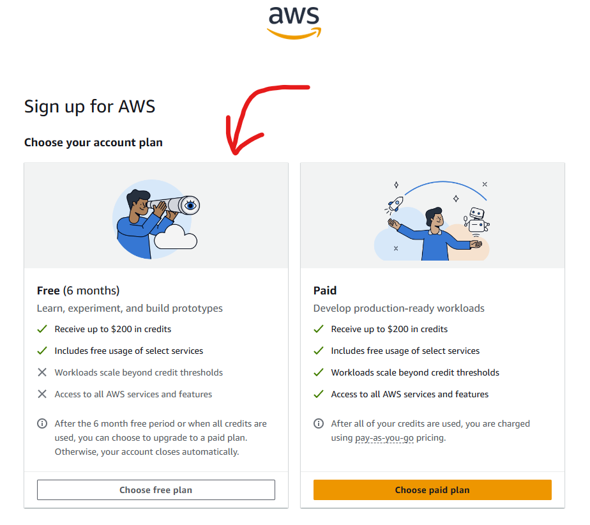
- Fill out billing information as follows
Field | What to enter
Full name | Enter full name
Organization name - optional | Enter name of organization
Country Code | Enter code of country you are in
Phone Number | Enter your phone number
Country or Region | Choose your country or region
Address line 1 | Enter in you address
City | Enter name of city you are in
State, Province, or Region | Choose State, Province, or Region which matches yours
Postal Code | Enter in postal code for your address
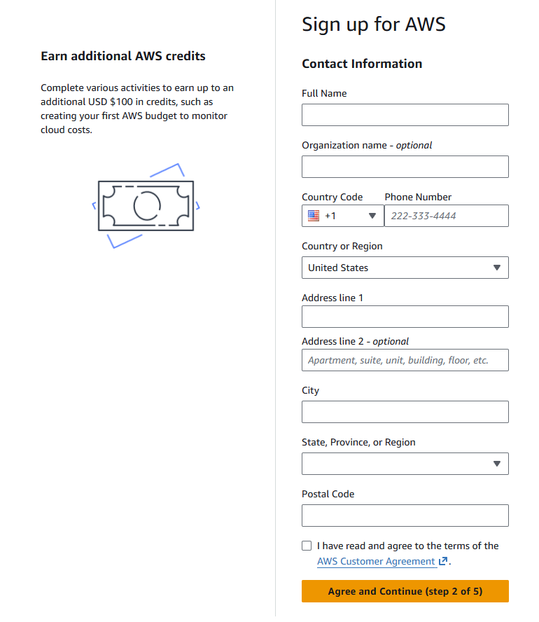
- Tick the “I have read and agree to the terms of the AWS Customer Agreement”
- Press “Agree and continue” button
- Fill in your billing information as follows:
Field | What to enter
Credit or Debit card number | Enter your card number here
Expiration date | Select the correct expiration date for your card
Security code | Enter in your CVV or CVC
Cardholder's name | Enter the name that the card is attached to
Billing address | Set the billing address to be correct with your card
- Click the “continue” button
- Click the “send SMS” button (make sure country or region code is correct and that your mobile number is correct)
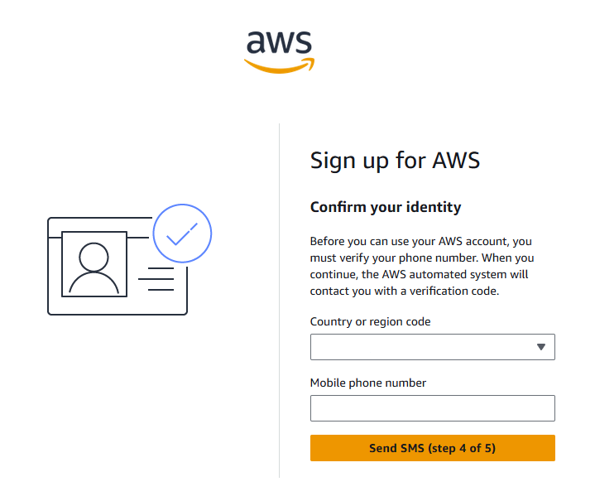
- Enter the SMS code into the field and press continue
- You should now be logged in and on the home page of your AWS account.

